MRD: Boat Renting

**Date last updated:** 2014-10-22

## Vision

## For those who enjoy boating, but do not have easy access to a boat, Barco is a new community marketplace that matches boat owners with willing renters.Unlike rental companies or boat shares, Barco will tap into the millions of unused boats in the world, lowering prices for renters and providing new found income to owners.

## Motivation

### Customer Segments

Boat Owners:

Boat owners do not currently have a good way to monetize their unused capacity. Their boat sits idle, and they continue to pay moorage and maintenance costs even when they’re deriving no utility from the vessel. Based on survey results, 2 out of 3 current boat owners would rent out their boat to accrue income. Our hypothesis is if we make this easy, boat owners will flock to our website to rent their boat in times when they don’t want to use it themselves.

Possible Renters:

Possible renters are casual recreationalists which want to use a boat 1-4 times per year, but rely on friends or acquaintances with access to a boat to fulfill these desires. Most of these individuals indicate that cost is the reason why they do not own a boat themselves, although other reasons prevail this is the primary concern. Our hypothesis is that if there was an easy way to rent a boat, these renters would be willing to pay.

Personas:

Family man Frank

Frank has a wife and two young children. Between their mortgage, payments on their SUV and mini-van, and saving for their children’s education, Frank doesn’t have anything leftover to buy a boat. Frank loves boating, and wants boating to be a part of his children’s lives as it was a big part of his. Frank would rather pay $200 for a half day of boating than $200 on schlepping the entire family to a Mariners game.

Socialite Sarah

Sarah loves spending time with her friends. She moved to the big city after college because there isn’t too big of a pond for her to flourish. Part of what makes Sarah so good as socializing is organizing fun events for her and her friends. Since they’re all still in their mid-20s, nobody has the capital to spend on a boat - but everybody that Sarah spends time with loves to go boating. Sarah and her friends would rather spend $200 on a half day of boating than just going to the bar again.

Possible Investors:

Investors invariably are non-boat owners that have expressed interest in buying a boat, but did not follow through with it due to the cost of ownership. Of survey respondents that had considered buying a boat (but did not end up buying one), cost was the sole reason why they did not follow through with the purchase. Our hypothesis is that Barco can help people realize the financial benefits of boat ownership, which opens up potential partnership opportunities with boat dealers and financiers.

### Unmet Needs

Boat Owners:

Boat owners currently do not have a seamless, safe and reliable way to rent their boats out to certified or professional boat captains. Their only option is to rent their boat on Craigslist, which has no insurance options and can be difficult to coordinate with potential captains and renters. Boat owners need to rely on accepting cash, or another payment sharing method which may lead to scams or potential non-payment. Lastly, boat owners have no way to verify the reliability and responsibility of renters.

Possible Renters:

Renters have a few options to rent a boat, all of them are more expensive than Barco and more cumbersome. As a result, possible renters do not rent boats as frequently as they would like. With Craigslist, they face the same issues of reliability and peace of mind as owners. With a boat rental agency, costs are higher and inventory (options) are fewer.

Possible Investors:

Not surprisingly, our survey discovered that individuals considering to buy a boat invariably decided not to due to cost. Our results also indicate that a segment of these non-owners would follow through with the purchase if costs were mitigated (or the purchase produced cash flows). This will increase the inventory available for renters.

### Existing Solutions

The current solutions that our target customers rely on, fall into two categories; the first is formal, like Seattle Boat Share where an agreement is documented between the renter and rentee, the second is informal, such as the process used on craigslist where no documentation is used and is relied solely on handshake agreements that aren’t enforceable. The two existing solutions currently, Seattle Boat Share and Craigslist, don’t meet the current customer needs in that people renting boats don’t have insurance, don’t necessarily know how to or want to drive a boat and it is very hard in both options to get a guarantee that the boat is in the condition that is listed. Seattle Boat Share falls short in that it requires rentees to become members of this club and there is a limited number of boats that can be rented. On the other hand, craigslist has a lot of boats available but no guarantees and/or insurance. An intermediary (such as Barco) in this market should be able to provide guarantees for both parties, such as the boats working condition and sees that the boat is returned in the same condition that it was rented in.

## Use Cases

*Use Case #1: Fun in the Sun!*

Jim loves to go out on the weekends with his friends. They regularly go to the beach, play sports, and even participate together in a local co-ed softball league. Last week their softball team won the Western Tacoma Regional Championship and Jim is looking for a special way for the team to celebrate. With the weather as great as it has been recently, he really would love to get out on the water. Jim downloads the Barco app and browses for the perfect boat. Once he picks out the perfect boat, he posts a message to his friends on Facebook and the event is on!

*Use Case #2: Gone Fishin’*

Sam and his father are avid fly fisherman and regularly make trips to the riverside in Snohomish to catch dinner. From the stories that they have heard at the tackle shop the fish simply will not stop biting at Wilson Lake. While they do not have a boat Sam and his father were excited to find out that they too could take part in the bounty of Wilson Lake when they discovered the Barco app. Next weekend they are looking forward to renting Adnan’s fishing boat while Adnan is out of town.

## Market Size

The core market for Barco is people who currently do not have access to boats but enjoy participating in recreational boating as well as the market of people who own boats and would like to reduce the cost of ownership. By researching census data, recreational boat registration data we have created an estimate of the total market size for this service. The scope of these estimates was focused on Washington State as the primary initial market and expanded to the United States as a larger target market.

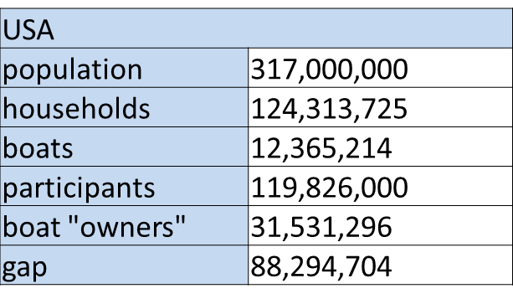

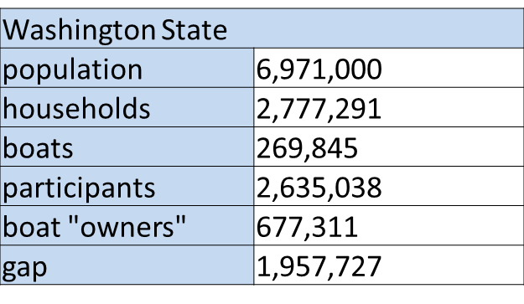The estimate of consumers in need of a boat rental service in the United States was created by comparing the number of people who live in a household that owns a boat to the number of people that participated in recreational boating at least once in a year. Using this method we found that the total market size for individuals who have some need for a boat rental service is roughly 88 million in the United States and nearly 2 million in Washington state. While some portion of this market is being served by other boat rental services we believe that this population is large enough to be an attractive market for further development.

There are over 12 million recreational boats registered in the United States and nearly 270,000 in Washington state. In Washington state 6.7% of households with an income between $50k and $74K own a recreational boat and 8.3% of households with an income between $74k and $99k own a boat. This is defines the prime demographic for boat owners that would be willing to rent their boats to others. Households below this range have materially lower percentage of boat ownership and households above this range have less need to subsidize cost of ownership. Barco estimates that there are roughly 150k households that fall within this target demographic. This market also satisfies minimum requirements for further development.

## Caveats / Risks

* Privacy Concerns- There are material concerns related to protecting customer information. Barco will need to ensure highly secure data storage and encryption for all customer records stored.
* Insurance- It is currently unclear how risk of injury and property damage will be handled by boat owners and renters and how Barco will minimize this factor.
* Competition- As this market is fairly large and the service that we are proposing is low cost to implement there is material risk of being beaten by a first mover in this space or a well-funded competitor.

## Strategic Information

The solutions proposed by Barco are very consistent with our organizational strategy. Our goal is to create products that enable customers to do things they wished they could. Facilitating the boating experience and making boats more accessible to non-owners is clearly in line with this strategy.

There are currently two products on the Seattle market with which Barco will compete. The first is the Seattle Boat Share. (SBS) This is a member’s only organization that allows people to pool their resources to more fully utilize boats. While this sounds similar to Barco, our research has shown that Seattle Boat Share does not offer a smooth experience that quickly connects people looking to rent a boat with people who have an available boat asset. Instead, SBS appears to be more like a home owners association for boats, but we are not sure. There is a yearly season pass that is prohibitively expensive for mass appeal at $3,200 for 2015. There are only 30 boats for the upcoming 2015 year, too. However, the Seattle Boat Share covers all maintenance, licensing fees, fueling, moorage, cleaning, etc. A major tenant of the SBS Is that there are also, “Never any limits on total use or daily use times.” This is clearly not a product for mass appeal and does not match up to Barco’s goals of expanding the market of those who are able to enjoy boating. Instead, Seattle Boat Share appears to target those who want to use a boat frequently but do not want to own one. This is supported by the fact that there are only 30 boats available for the 2015 year. A final note of importance is that from their website, it unclear who owns the boats that SBS has in stock: does SBS own them or do owners put their resources together and rent out when they want to?

The second product Barco will compete with is Craigslist. Craigslist has a plethora of owners willing to rent their boat(s) to people at a variety of prices. While this solution has more of the depth and breadth that will allow Barco to tap into mass appeal for boating, Craigslist falls short on many critical areas. Whereas the Seattle Boat Share covers insurance, moorage fees, safety equipment, etc, Craigslist does not. Every transaction is informal and thus up to individual discretion. This dramatically increases the risk associated with renting a boat through Craigslist. Another aspect about Craigslist is that there is no method to determine the quality of the boat someone is renting. This goes back to the fact that there are no formal agreements in place when renting a boat through this existing solution.

## Go or No Go?

Market size and early market response are promising enough to move forward with this project. The Barco team is convinced at this point that the pain point for customers is authentic and addressable. At this point the team is going to move forward with development of an MVP to further test market interest and develop deeper insights into customer needs.